VOIP lab experiment#8
Creating an inbound route

Installation and Repair of Telecommunications Equipment

Name of student:________________
Group Number:_________________
Date:_________________________

The purpose of the lab is to create an inbound rate for the company in the PBX.
Go to Inbound Routes in the Menu connectivity

- Enter a description
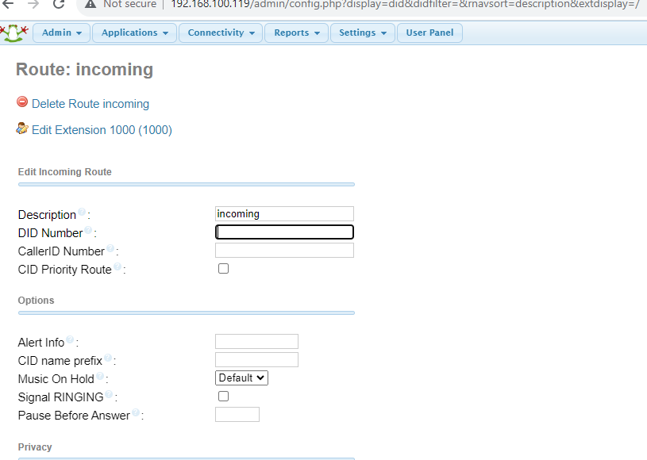

- Enter a DID number: leave blank

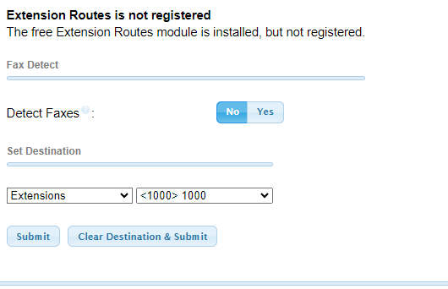
- Choose an extension in set destination

- Submit and apply configuration

